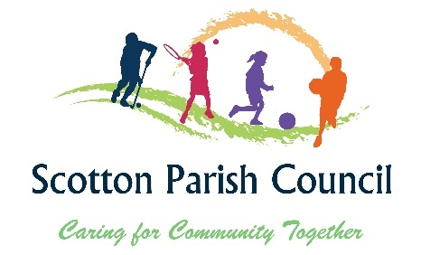
Scotton Village Hall, Hawthorne Ave, Scotton, Catterick Garrison. DL9 3NE
Email: clerk@scotton-pc.gov.uk Tel 07871341649

MINUTES FOR THE VILLAGE HALL AND OUTDOOR OPEN SPACES MEETING OF SCOTTON PARISH COUNCIL
Held on Monday the 7th of July 2025 after the Monthly meeting

Present Cllr Whitehead, Cllr Fulton, Cllr Bennett, Cllr Dale, Cllr Paley

- To appoint a chair for the meeting – Proposed by Cllr Dale and Cllr Fulton to elect Cllr Whitehead.

- To receive apologies and accept reasons for absence - Cllr Greensmith, Cllr Kitching

- To receive councillors’ declarations of interests – Cllr Paley 4.1

- To discuss and consider outdoor spaces
  - To discuss and consider allotment updates – number 15 has given up allotment and it has been relet
  - To discuss and consider Meanee play park updates – still waiting to hear from Parish Liaison officer. Have spoken to the parks officer and she has done all she can.
  - To discuss and consider play park inspection – RESOLVED to look at the park inspection when looking in August walk about
  - To discuss and consider Hawthorne Park – Fence is done, look at insurance for the zip wire and annual checking.
  - To discuss and consider Scotton field – Sill waiting for a response
  - To discuss and consider Village Hall car park – discussions took place and it was RESOLVED to look at the parking in the August walk about.

- To discuss and consider Summer fair
5.1 To discuss and consider garden competition – It has been advertised on facebook and various places so far only 3 applicants

- To discuss and consider next items for the agenda -

The Village hall and outdoor spaces committee will Consider the impact on biodiversity in the decisions it makes in committee and working group meetings. Decisions will be informed and in-line with the Council’s Bio-diversity action plan. It will seek to minimise adverse impacts on biodiversity as a result of any decisions, and Committee activities and will identify opportunities to increase biodiversity when practicable
Filming, photographing and recording is allowed at Parish Council Meetings under the Openness of Local Government Bodies Regulations 2014.

